**Hi there! The time has come to take your diagnostics exam! The purpose of this exam is to help you see the progress you have made during this course. Enjoy!**

**Instructions: Read the sentences carefully and select the word that works best in the context of the sentence.**

1. There’s ___C___ apple on the table. A. Some B. a C. an
2. There is ___C__water in the fridge A. much B. many C. a lot of D.a E. a little
3. Would you like _____E_____ grapes?
   1. much B. any C. many D.a little E. some
4. Which words means 75% of the people.
   1. most of B. some of C. a lot of D. half of E. anyone
5. ____C______ needs to feel loved.
   1. Somebody B. Anyone C. Everybody D. No one E. Everything
6. I can't find my phone ______A_____.
   1. anywhere B.everywhere C.somewhere D. nowhere E.none
7. I'm sorry, we don't have ____D_____ sodas.
   1. some B. none C.no D. any E. a little
8. Which word means 0 % of the time?
   1. none B. never C. rarely D. seldomly E. occasionally
9. I have been living here ___C____ three years.
   1. since B. during C. for D. yet E. still
10. Are you ____B___looking for a job?
    1. yet B. been C. have D. still
11. When do we use "will"?
    1. All future plans B. Spontaneous future plans C. Confirmed future plans

D. When talking about desires

1. What is the comparative of "bad"?

A. badder B. more bad C. baddest D. worse E. worst

1. What is the superlative of "happy"?

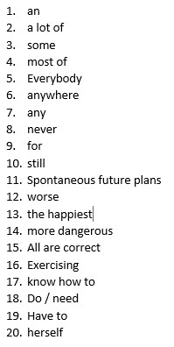A. the happiest B. happier C. happyer D. the happier E. the happiest than

1. Kayaking is ______C______ than painting.

A. dangerouser B. the most dangerous C.most dangerous D. danger E. more dangerous

1. What makes a compound noun with the word "any" ?
   1. thing B. body C. one D. more E. All are correct
2. ______C_____ is good for your health.
   1. Exercising B. To exercise C. Having exercise D. Making exercise
3. I _____A___ride a horse.
   1. know how to B. knows how to C. know to D. know how E. knows to
4. ________you_______ help?
   1. Does / need B. Do / need C. Do / needs D. Does / needs E. Can / need
5. Which is used to talk about a rule?
   1. Have to B. Don't have to C. Could D. Should

E. Shouldn't

1. Jane is talking to ____A______
   1. herself B. myself C. oneself D. himself

E. ourselves